Practical solutions: Network meta-analysis of rare events

Oxford 2019

## R packages

We will use the **netmeta** command to run all network meta-analyses.

library(netmeta)

## Data

Load the data by running the following command.

data(Gurusamy2011)

The data is from a NMA regarding methods to decrease blood loss and blood transfusion requirements for patients with liver transplantation.

Have a look at the dataset. Can you calculate the total event rate across all studies and arms?

# Inverse variance NMA

Now run the following R commands to fit an inverse-variance network meta-analysis model.

p1 = pairwise(treatment, death, n, studlab = study,  
 data = Gurusamy2011, sm = "OR")  
IV1 = netmetabin(p1, ref = "Control/Placebo", method = "Inverse",  
 comb.random = FALSE)

## Comparisons not considered in network meta-analysis:  
## studlab treat1 treat2 TE seTE  
## Pugliese 2007 Control/Placebo rFVIIa NA NA  
## Himmelreich 1992 Aprotonin Control/Placebo NA NA  
## Williamson 1999 Control/Placebo Solvent detergent plasma NA NA

Plot the network graph

netgraph(IV1, seq = "optimal", col = "black", plastic = FALSE,  
 points = TRUE, pch = 21, cex.points = 3, col.points = "black",  
 bg.points = "gray", thickness = "se.fixed",  
 multiarm = FALSE, number.of.studies = TRUE)

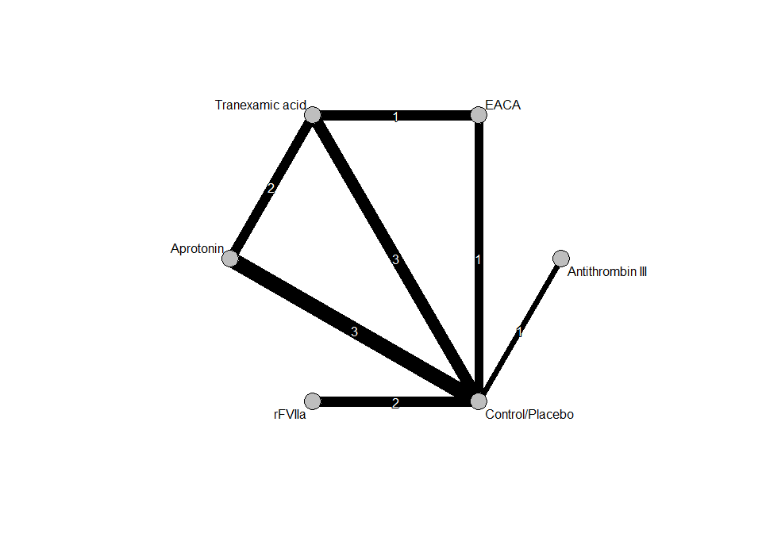 Run the following commands to see results

summary(IV1)

## Number of studies: k = 11  
## Number of treatments: n = 6  
## Number of pairwise comparisons: m = 13  
## Number of designs: d = 6  
##   
## Fixed effects model  
##   
## Treatment estimate (sm = 'OR', comparison: other treatments vs 'Control/Placebo'):  
## OR 95%-CI  
## Antithrombin III 0.2148 [0.0094; 4.8918]  
## Aprotonin 0.3998 [0.1477; 1.0820]  
## Control/Placebo . .  
## EACA 0.8144 [0.1558; 4.2576]  
## rFVIIa 1.5377 [0.3140; 7.5300]  
## Tranexamic acid 0.9046 [0.2763; 2.9612]  
##   
## Quantifying heterogeneity / inconsistency:  
## tau^2 = 0; I^2 = 0%  
##   
## Tests of heterogeneity (within designs) and inconsistency (between designs):  
## Q d.f. p-value  
## Total 3.79 7 0.8032  
## Within designs 2.72 5 0.7427  
## Between designs 1.07 2 0.5853

and get the league table

netleague(IV1, digits=2)

## League table (fixed effect model):  
##   
## Antithrombin III . 0.21 [0.01; 4.89]  
## 0.54 [0.02; 14.28] Aprotonin 0.51 [0.17; 1.54]  
## 0.21 [0.01; 4.89] 0.40 [0.15; 1.08] Control/Placebo  
## 0.26 [0.01; 9.06] 0.49 [0.08; 2.99] 1.23 [0.23; 6.42]  
## 0.14 [0.00; 4.65] 0.26 [0.04; 1.70] 0.65 [0.13; 3.18]  
## 0.24 [0.01; 6.72] 0.44 [0.12; 1.58] 1.11 [0.34; 3.62]  
##   
## . . .  
## . . 0.23 [0.04; 1.39]  
## 1.44 [0.22; 9.41] 0.65 [0.13; 3.18] 1.67 [0.40; 7.00]  
## EACA . 1.00 [0.19; 5.26]  
## 0.53 [0.05; 5.25] rFVIIa .  
## 0.90 [0.19; 4.28] 1.70 [0.23; 12.34] Tranexamic acid

# Mantel-Haenszel NMA

In order to run a MH-NMA run the following:

MH1 = netmetabin(p1, ref = "Control/Placebo")

and check results:

summary(MH1)

## Number of studies: k = 10  
## Number of treatments: n = 5  
## Number of pairwise comparisons: m = 12  
## Number of designs: d = 5  
##   
## Fixed effects model (Mantel-Haenszel method)  
##   
## Treatment estimate (sm = 'OR', comparison: other treatments vs 'Control/Placebo'):  
## OR 95%-CI  
## Aprotonin 0.3552 [0.1269; 0.9946]  
## Control/Placebo . .  
## EACA 0.7365 [0.1394; 3.8916]  
## rFVIIa 1.5375 [0.3139; 7.5317]  
## Tranexamic acid 0.7665 [0.2250; 2.6113]  
##   
## Quantifying heterogeneity / inconsistency:  
## tau^2 = NA  
##   
## Test of heterogeneity / inconsistency:  
## Q d.f. p-value  
## 1.88 2 0.3907

netleague(MH1, digits=2)

## League table (fixed effect model):  
##   
## Aprotonin 0.47 [0.15; 1.45] .  
## 0.36 [0.13; 0.99] Control/Placebo 1.44 [0.22; 9.41]  
## 0.48 [0.08; 3.08] 1.36 [0.26; 7.17] EACA  
## 0.23 [0.03; 1.53] 0.65 [0.13; 3.19] 0.48 [0.05; 4.78]  
## 0.46 [0.12; 1.85] 1.30 [0.38; 4.44] 0.96 [0.20; 4.59]  
##   
## . 0.16 [0.02; 1.40]  
## 0.65 [0.13; 3.19] 2.13 [0.54; 8.42]  
## . 1.00 [0.19; 5.26]  
## rFVIIa .  
## 2.01 [0.27; 14.92] Tranexamic acid

forest(MH1)

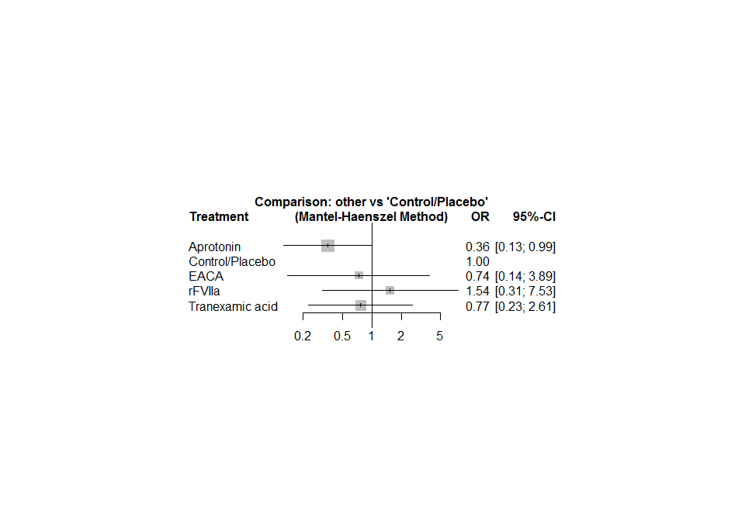

Check results with the inverse variance NMA results. Do you see any differences? Where do you attribute them?

# Non-central hypergeometric NMA

Now repeat the analysis using the non-central hypergeometric NMA model:

NCH1 = netmetabin(p1, ref = "Control/Placebo", method = "NCH")  
summary(NCH1)

## Number of studies: k = 10  
## Number of treatments: n = 5  
## Number of pairwise comparisons: m = 12  
## Number of designs: d = 5  
##   
## Fixed effects model (Non-central hypergeometric distribution)  
##   
## Treatment estimate (sm = 'OR', comparison: other treatments vs 'Control/Placebo'):  
## OR 95%-CI  
## Aprotonin 0.3598 [0.1350; 0.9590]  
## Control/Placebo . .  
## EACA 0.7693 [0.1568; 3.7731]  
## rFVIIa 1.5093 [0.3175; 7.1739]  
## Tranexamic acid 0.8059 [0.2677; 2.4262]  
##   
## Quantifying heterogeneity / inconsistency:  
## tau^2 = NA  
##   
## Test of heterogeneity / inconsistency:  
## Q d.f. p-value  
## <NA> <NA> --

netleague(NCH1)

## League table (fixed effect model):  
##   
## Aprotonin 0.4728 [0.1538; 1.4537]  
## 0.3598 [0.1350; 0.9590] Control/Placebo  
## 0.4677 [0.0827; 2.6449] 1.2999 [0.2650; 6.3756]  
## 0.2384 [0.0378; 1.5032] 0.6626 [0.1394; 3.1492]  
## 0.4465 [0.1368; 1.4571] 1.2408 [0.4122; 3.7354]  
##   
## . .  
## 1.4444 [0.2217; 9.4127] 0.6504 [0.1328; 3.1861]  
## EACA .  
## 0.5097 [0.0550; 4.7249] rFVIIa  
## 0.9545 [0.2154; 4.2300] 1.8727 [0.2776; 12.6348]  
##   
## 0.1633 [0.0191; 1.3962]  
## 2.1333 [0.5402; 8.4247]  
## 1.0000 [0.1900; 5.2631]  
## .  
## Tranexamic acid

forest (NCH1)

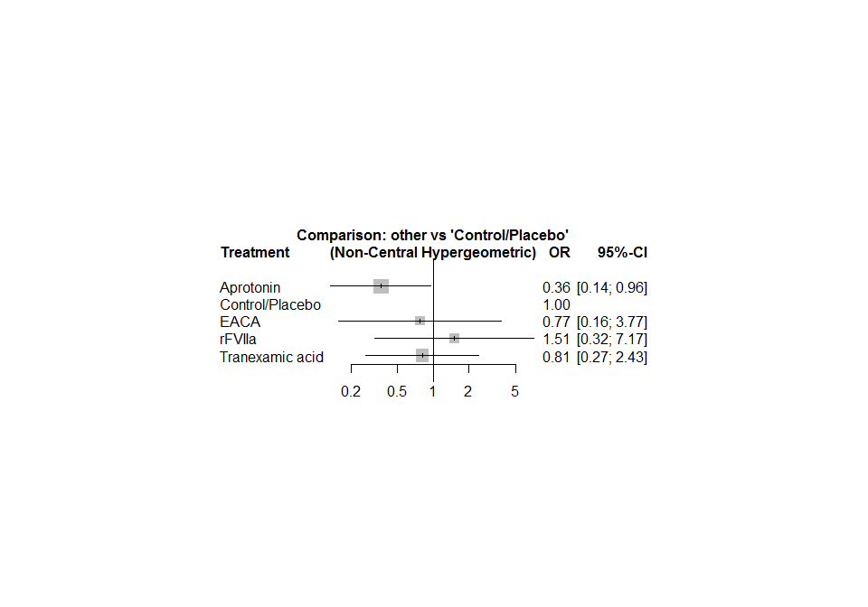

Compare results with the previous analyses

## Inconsistency evaluation

In order to run the SIDDE approach to inconsistency, run the following command:

print(netsplit(MH1), show = "both", ci = TRUE, overall = FALSE)

## SIDDE method to split direct and indirect evidence  
##   
## Fixed effect model:   
##   
## comparison k direct 95%-CI indir. 95%-CI.1 RoR 95%-CI.2 z p-value  
## Aprotonin:Control/Placebo 3 0.4728 [0.1538; 1.4537] 0.0792 [0.0060; 1.0390] 5.9692 [0.3599; 98.9933] 1.25 0.2125  
## Aprotonin:Tranexamic acid 2 0.1633 [0.0191; 1.3962] 0.9745 [0.1593; 5.9627] 0.1675 [0.0101; 2.7783] -1.25 0.2125  
## Tranexamic acid:Control/Placebo 3 0.4688 [0.1187; 1.8511] 2.8960 [0.2569; 32.6456] 0.1619 [0.0100; 2.6213] -1.28 0.2000  
##   
## Legend:  
## comparison - Treatment comparison  
## k - Number of studies providing direct evidence  
## direct - Estimated treatment effect (OR) derived from direct evidence  
## indir. - Estimated treatment effect (OR) derived from indirect evidence  
## RoR - Ratio of Ratios (direct versus indirect)  
## z - z-value of test for disagreement (direct versus indirect)  
## p-value - p-value of test for disagreement (direct versus indirect)

Can you interpret the results?

If you have time, repeat the analyses for a different dataset:

data("Dong2013")